1. Variáveis de ambiente:
2. Criação de grupos:
3. Criação de Usuário:
4. Bash profile do usuário grid nos 2 nós:

Nó 1:

umask 022

#TZ=America/Sao_Paulo; export TZ

ORACLE_HOSTNAME=s-sebu86.localdomain; export ORACLE_HOSTNAME

ORACLE_SID=+ASM1; export ORACLE_SID

ORACLE_BASE=/u01/crs/oracle; export ORACLE_BASE

ORACLE_HOME=/u01/crs/product/11.2/crs_1; export ORACLE_HOME

ORA_CRS_HOME=$ORACLE_HOME; export ORA_CRS_HOME

ORACLE_PATH=/u01/rdbms/oracle/common/oracle/sql:.:$ORACLE_HOME/rdbms/admin

export ORACLE_PATH

#PATH=$PATH:$ORACLE_HOME/bin: export PATH

TNS_ADMIN=$ORACLE_HOME/network/admin; export TNS_ADMIN

NLS_LANG=American_America.WE8ISO8859P1; export NLS_LANG

NLS_CHARACTERSET=WE8ISO8859P1; export NLS_CHARACTERSET

#LD_LIBRARY_PATH=/volorahome/app/oracle/product/10.1/lib:/volorahome/crs/oracle/product/10.1/crs_1/lib:/volorahome/app/oracle/product/10.1/lib32:$LD_LIBRARY_PATH; export LD_LIBRARY_PATH

#LIBPATH=/volorahome/app/oracle/product/10.1/lib:/volorahome/crs/oracle/product/10.1/crs_1/lib:/volorahome/app/oracle/product/10.1/lib32:$LIBPATH; export LIBPATH

PATH=$PATH/usr/bin:/bin:/usr/bin/X11:/usr/sbin:/sbin:$ORACLE_HOME:$ORACLE_HOME/bin:$ORACLE_BASE

export PATH

EDITOR=vi

export EDITOR

Nó 2:

umask 022

#TZ=America/Sao_Paulo; export TZ

ORACLE_HOSTNAME=s-sebu86.localdomain; export ORACLE_HOSTNAME

ORACLE_SID=+ASM1; export ORACLE_SID

ORACLE_BASE=/u01/crs/oracle; export ORACLE_BASE

ORACLE_HOME=/u01/crs/product/11.2/crs_1; export ORACLE_HOME

ORA_CRS_HOME=$ORACLE_HOME; export ORA_CRS_HOME

ORACLE_PATH=/u01/rdbms/oracle/common/oracle/sql:.:$ORACLE_HOME/rdbms/admin

export ORACLE_PATH

#PATH=$PATH:$ORACLE_HOME/bin: export PATH

TNS_ADMIN=$ORACLE_HOME/network/admin; export TNS_ADMIN

NLS_LANG=American_America.WE8ISO8859P1; export NLS_LANG

NLS_CHARACTERSET=WE8ISO8859P1; export NLS_CHARACTERSET

#LD_LIBRARY_PATH=/volorahome/app/oracle/product/10.1/lib:/volorahome/crs/oracle/product/10.1/crs_1/lib:/volorahome/app/oracle/product/10.1/lib32:$LD_LIBRARY_PATH; export LD_LIBRARY_PATH

#LIBPATH=/volorahome/app/oracle/product/10.1/lib:/volorahome/crs/oracle/product/10.1/crs_1/lib:/volorahome/app/oracle/product/10.1/lib32:$LIBPATH; export LIBPATH

PATH=$PATH/usr/bin:/bin:/usr/bin/X11:/usr/sbin:/sbin:$ORACLE_HOME:$ORACLE_HOME/bin:$ORACLE_BASE

export PATH

EDITOR=vi

export EDITOR

1. Criação dos diretórios nos 2 nós

mkdir -p /u01/crs/oracle

mkdir -p =/u01/crs/product/11.2/crs_1

1. Configuração do asmlib

sudo /etc/init.d/oracleasm -configure –l

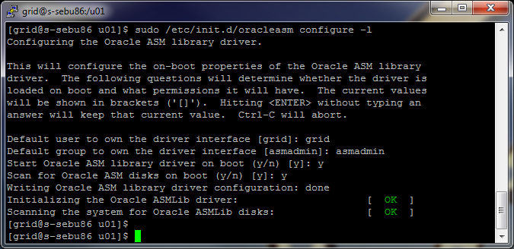

1. Criação dos discos no asmlib

Lista dos discos:

Disk /dev/sdb: 429.5 GB, 429523992576 bytes

Disk /dev/sdc: 429.5 GB, 429523992576 bytes

Disk /dev/sdd: 213.6 GB, 213674622976 bytes

Disk /dev/sde: 429.5 GB, 429523992576 bytes

Disk /dev/sdf: 5368 MB, 5368709120 bytes

Disk /dev/sdg: 21.4 GB, 21474836480 bytes

Disk /dev/sdh: 213.6 GB, 213674622976 bytes

Executar o fdisk nos discos

fdisk /dev/sdb

Command (m for help): n  
Command action  
e extended  
p primary partition (1-4)  
p  
Partition number (1-4): 1  
First cylinder (1-652, default 1): press "enter"   
Using default value 1  
Last cylinder or +size or +sizeM or +sizeK (1-652, default 652): press "enter"   
Using default value 652  
  
Command (m for help): w  
The partition table has been altered!  
  
Calling ioctl() to re-read partition table.  
Syncing disks.  
Repetir a operação para os /dev/sdc, /dev/sdd, /dev/sde, /dev/sdf, /dev/sdg

Comandos para criação dos discos no asmlib

sudo /etc/init.d/oracleasm createdisk VOLCRS1 /dev/sdf1

sudo /etc/init.d/oracleasm createdisk VOLPROD1 /dev/sdb1

sudo /etc/init.d/oracleasm createdisk VOLPROD2 /dev/sdc1

sudo /etc/init.d/oracleasm createdisk VOLPROD3 /dev/sdd1

sudo /etc/init.d/oracleasm createdisk VOLPROD4 /dev/sdg1

sudo /etc/init.d/oracleasm createdisk VOLFRA1 /dev/sde1

sudo /etc/init.d/oracleasm createdisk VOLFRA2 /dev/sdh1

1. Executar o instalador do grid. Executar o runInstaller.

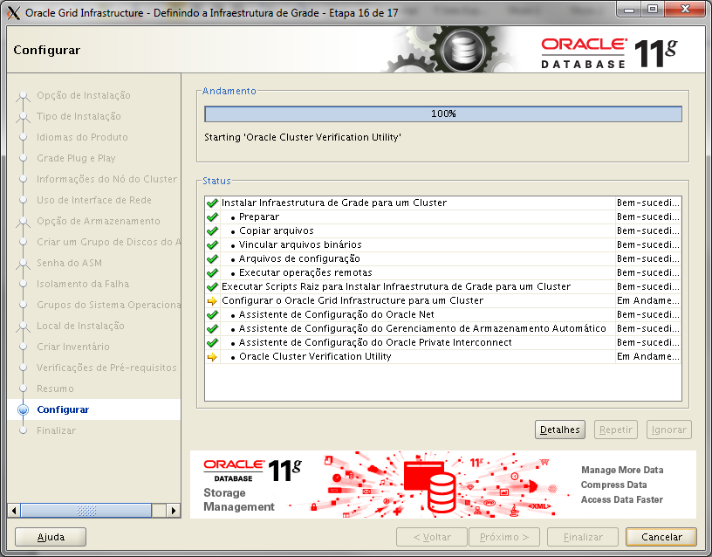

1. Executar asmca no usuário grid do nó 1:

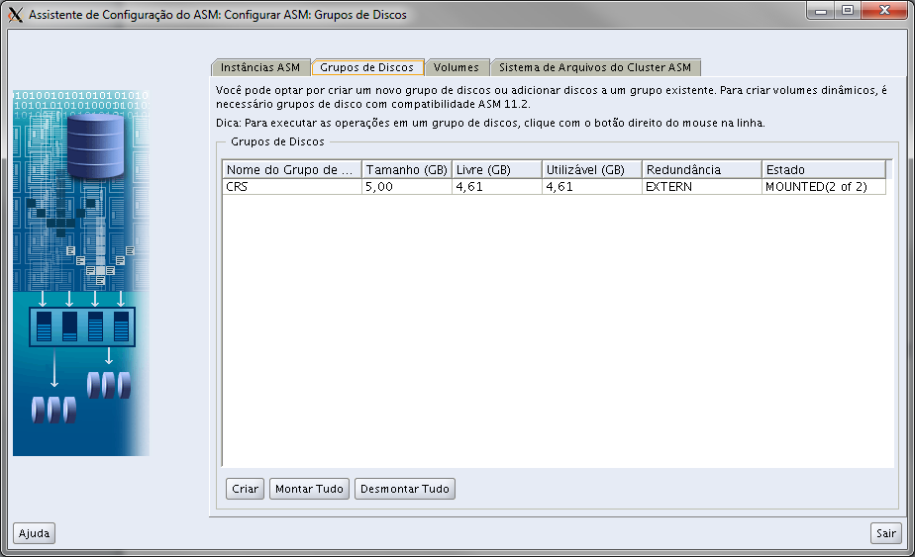

Clicar em criar

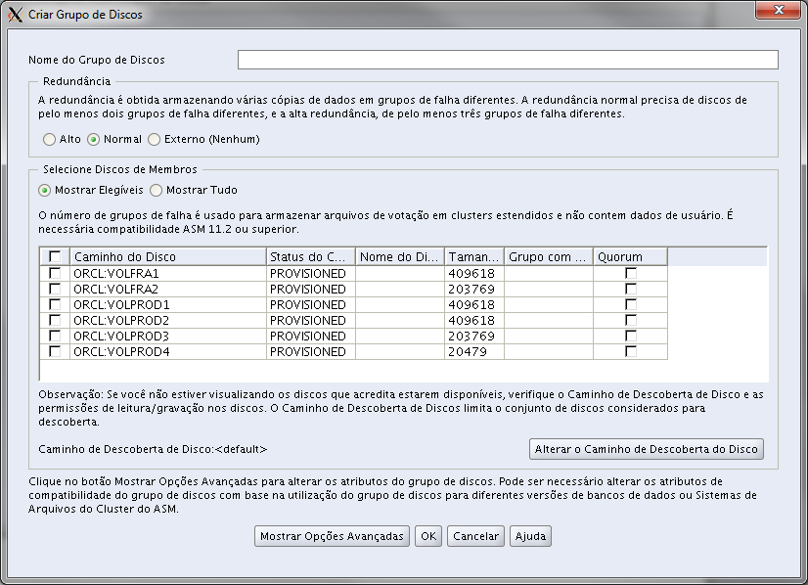

Digitar RACDB e escolher os discos com VOLPROD* marcar a opção “externo” e clicar em OK

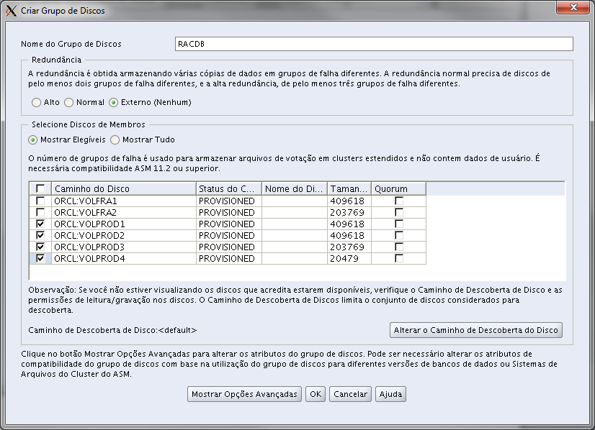

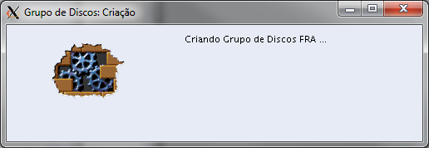

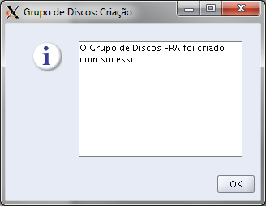

Digitar FRA e escolher os discos com VOLFRA* marcar a opção “externo” e clicar em OK

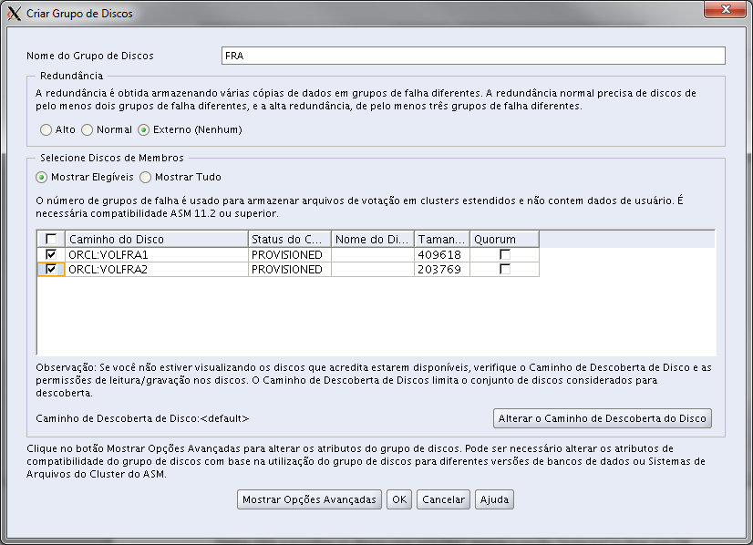





Clicar em “Sair”

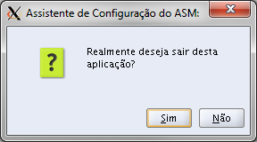

1. chown oracle.oinstall /u01 nos 2 servidores
2. Como usuário oracle criar o .bash_profile
3. Criar os diretórios

mkdir -p /u01/rdbms/oracle/product/11.2/dbhome_1

1. Executar o runInstaller. ./runInstaller –ignoreInternalDriverError

